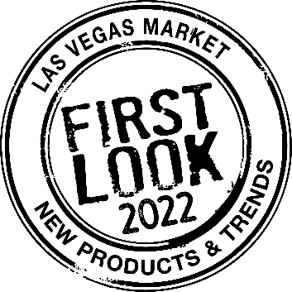
SUMMER 2022 LAS VEGAS MARKET
FIRST LOOK is Las Vegas Market’s premier products and trends program, highlighting exhibitor products to buyers through relevant themes/trends each market cycle. FIRST LOOK returns with a pre-market webinar, booklet, onsite seminar, tour & product display.
Contact and Product Information
Company Name:
Submitted By:
Email Address:
Phone:
Showroom Name (If different from company name):
Building and Showroom Number:
My product submissions are available to feature in the Summer 2022 displays: | ☐ Yes  ☐ No
Photo File Name:
Product Specifications:
Product Description:
(Optional) Please share the link to the product in the LVM Exhibitor Directory

Photo File Name:
Product Specifications:
Product Description:
(Optional) Please share the link to the product in the LVM Exhibitor Directory

Photo File Name:
Product Specifications:
Product Description:
(Optional) Please share the link to the product in the LVM Exhibitor Directory

Photo File Name:
Product Specifications:
Product Description:
(Optional) Please share the link to the product in the LVM Exhibitor Directory

Please submit this form along with high-resolution imagery (at least 5”x7”, 300 dpi) and the product descriptions form by to both Deborah Bisbee at dbisbee@imcenters.com and FIRST LOOK curator Julie Smith Vincenti at julie@ninemusesmedia.com.

