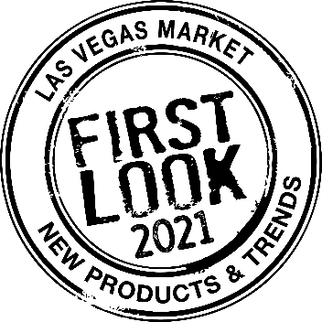
2021 SUMMER LAS VEGAS MARKET
FIRST LOOK is Las Vegas Market’s premier products and trends program, highlighting exhibitor products to buyers through relevant themes/trends each market cycle. FIRST LOOK product displays return to Las Vegas Market August 22 - 26, and all tenants are encouraged to submit products!
Contact and Product Information
Company Name:
Submitted By:
Email Address:
Phone:
Showroom Name (If different from company name):
Building and Showroom Number:
My product submissions are available to feature in the Summer 2021 displays: | ☐ Yes  ☐ No
Photo File Name:
Product Specifications:
Product Description:
(Optional) Please share the link to the product in the LVM Exhibitor Directory

Photo File Name:
Product Specifications:
Product Description:
(Optional) Please share the link to the product in the LVM Exhibitor Directory

Photo File Name:
Product Specifications:
Product Description:
(Optional) Please share the link to the product in the LVM Exhibitor Directory

Photo File Name:
Product Specifications:
Product Description:
(Optional) Please share the link to the product in the LVM Exhibitor Directory

